AI‑Driven Personalization & Marketing Automation — Arc42 Architecture
Scenario: E‑commerce campaigns target 150M customers across channels. Current personalized flows deliver 22% conversion; goal is 30%+ with real‑time, context‑aware decisioning while maintaining trust, fairness, and compliance.

1. Goals & Quality Requirements (Arc42: 1)

Business goals
- G1: Lift conversion from 22% → 30%+ in Q4 (Black Friday readiness).
- G2: Increase campaign velocity (experiment turnaround ≤ 24h).
- G3: Improve CLV and AOV via next-best-action (NBA) and next-best-offer (NBO).
- G4: Preserve customer trust: transparent AI, consent-aware, compliant.

Primary NFRs (ISO/IEC 25010-aligned, mapped to KPIs)
- Latency: end-to-end decision p95 ≤ 150 ms (realtime web/app); ≤ 3 s for email batch.
- Throughput: sustain 15k decisions/s burst (Black Friday), scale to 50k/s with horizontal autoscale.
- Availability: 99.95% decision service; graceful degradation to rule-based fallback ≤ 50 ms.
- Accuracy: online AUC/PR ↑ vs baseline; uplift ≥ +8 pp absolute conversion on targeted segments.
- Fairness: disparate impact ratio in approved bands (0.8–1.25) across protected proxies.
- Privacy/Compliance: GDPR/CCPA consent enforcement; DSAR < 30 days, RTBF < 48 h.
- Explainability: per-decision reason codes; global model cards updated per release.
- Cost efficiency: <$1.50 per 1k decisions average; <$0.20 per 1k batch scores.
- Observability: traceable ID per decision; SLO alerts in < 5 min detection.
- Experimentation: ship ≥ 20 concurrent experiments, stats power computations automated.

2. Constraints & Context (Arc42: 2–3)

Constraints
- Use existing CDP/CRM and ESP/SMS providers; no PII leaves region.
- On-prem + cloud hybrid allowed; production data in region; model training can use VPC cloud.
- Enforce consent at read time in feature store and at serve time (policy as code).
- Align with NIST AI RMF and internal risk committee.

Business Context

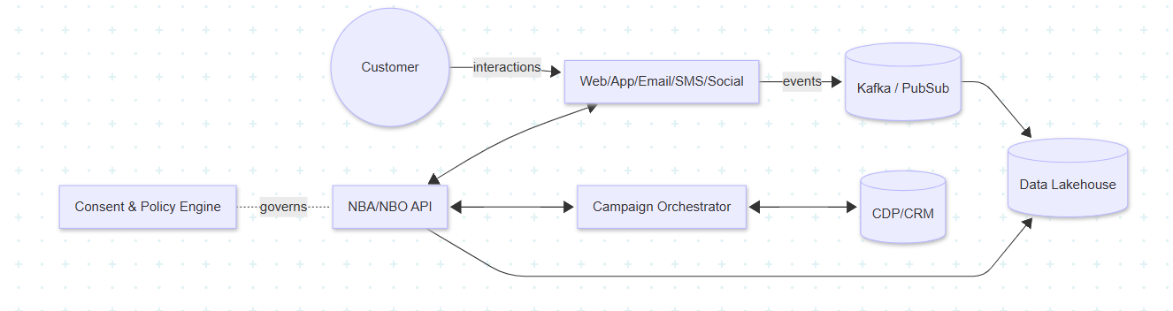

Technical Context
- Inputs: clickstream, session context, catalog, inventory, promotions, fraud signals.
- Outputs: real-time recommendations, treatments, subject lines, suppression lists, reason codes.

3. Solution Strategy (Arc42: 4)
- Streaming first: features computed via low-latency stream processing; online feature store.
- Model serving via stateless microservice with A/B switch, shadow deploys, canary, and rollbacks.
- Policy-guarded AI: consent, PII access control, fairness checks before and after serving.
- Resilience-first: circuit breakers + rules engine fallback (deterministic).
- MLOps: versioned data/model/feature lineage; automated eval & promotion gates.
- Metrics-driven: every decision emits telemetry with treatment, score, reason codes, consent status.

4. Building Block View (Arc42: 5)
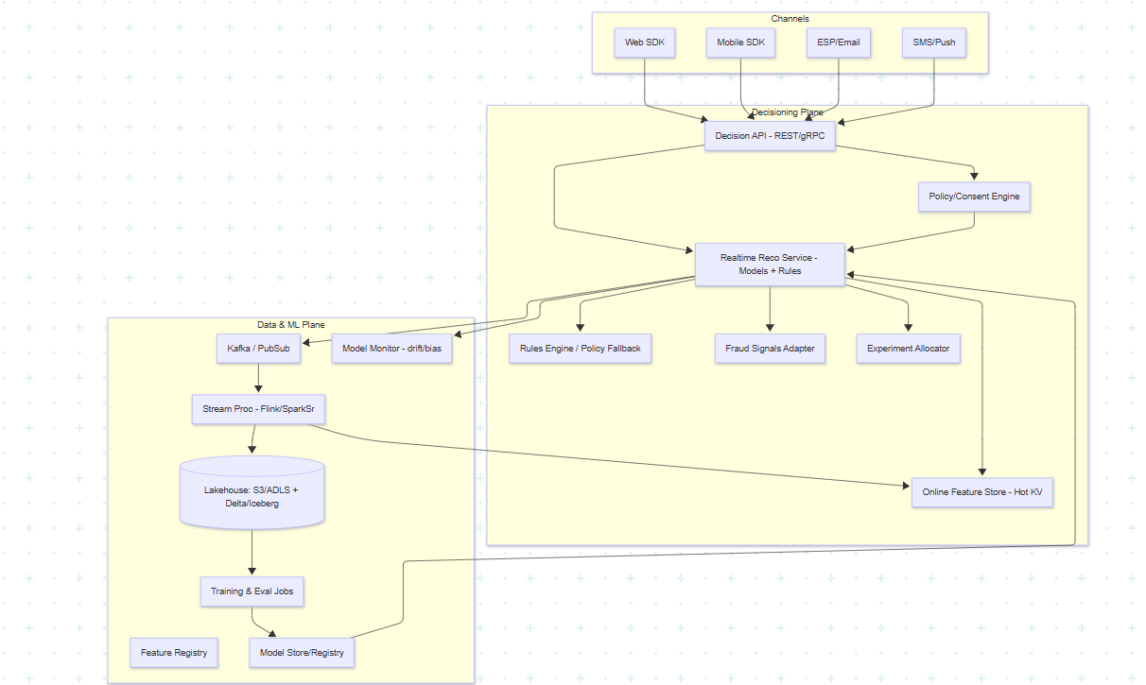

Key responsibilities
- Decision API: low-latency gateway; authZ, schema validation, rate limits.
- Realtime Reco Service: ensemble models (ranking + re-ranking + constraints).
- Experiment Allocator: subject assignment, bucketing, CUPED/variance reduction support.
- Policy/Consent Engine: purpose-based access, data minimization, explainability toggles.
- Feature Store: online (sub-10ms GET) + offline (training parity) with registry.
- Model Monitor: data & prediction drift, fairness metrics, SLO breaches.

5. Runtime Scenarios (Arc42: 6)
Realtime personalization request (web/app)
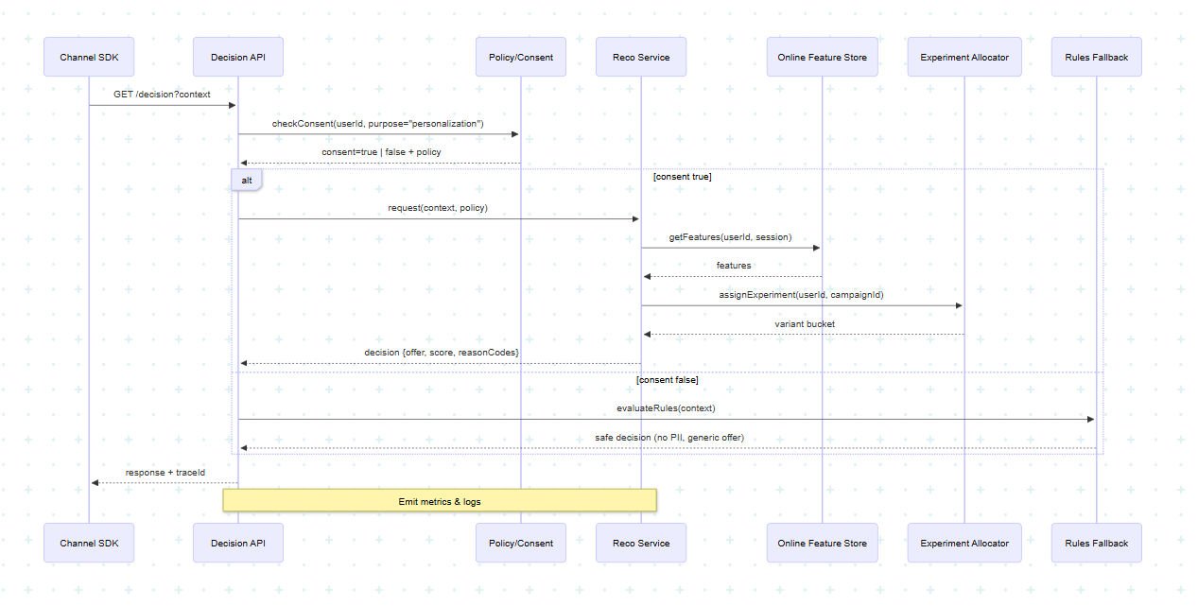
Batch email selection (daily): Spark/Flink job aggregates features & recency, filters by consent, writes suppression/target lists to ESP; model scoring via distributed batch; outputs reasons for audit.

6. Deployment View (Arc42: 7)
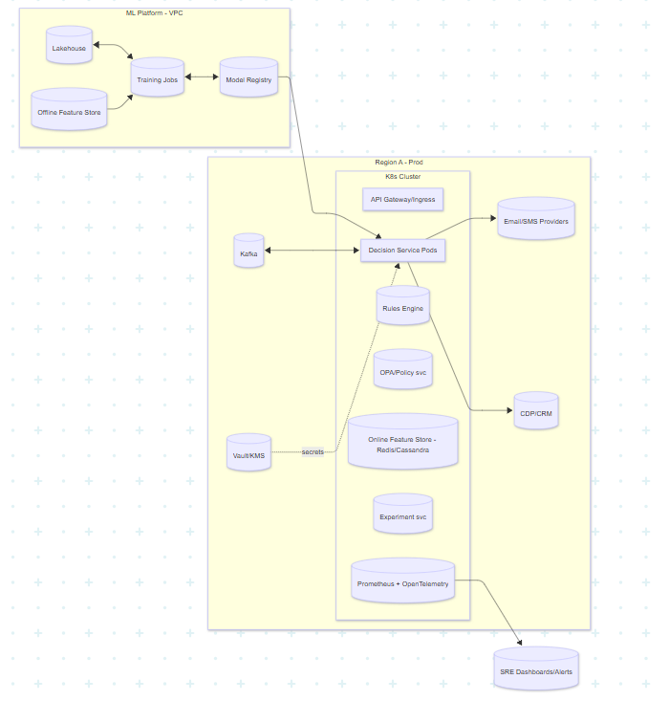

7. Cross‑Cutting Concepts (Arc42: 8)
- Data & Feature Management: Feature Registry (entities, feature definitions, owners, SLAs). Point-in-time correct joins; training/serving skew checks.
- Experimentation: bucketing libraries (deterministic hashing), sequential testing guards; auto-stop on harmful lift.
- Explainability: per-decision reason codes; global model card (intended use, risks, data).
- Trust & Safety: policy as code (OPA/Rego) for consent, purpose limitation, channel suitability; fraud signal integration for suppression.
- Resilience: bulkheads, circuit breakers, synthetic defaults when features missing; idempotent APIs; degraded mode selects safe generic offers.
- Observability: OpenTelemetry tracing; decision traceId; dashboards for p95, errors, skew, drift, fairness.
- Security: mTLS, JWT; PII separated and tokenized; encryption at rest; no PII in logs.
- Cost controls: autoscaling on QPS & lag; cache hot features; batch where acceptable; spot nodes for training.

8. Quality Scenarios (Arc42: 10)
Quality | Scenario | Metric / Acceptance
Performance | Black Friday spike to 25k req/s | p95 ≤ 150 ms; error rate ≤ 0.5%
Availability | Feature store node loss | < 60 s failover, fallback active
Accuracy | New model rollout | Uplift ≥ +3 pp; auto-rollback on CTR drop >2 pp
Fairness | Protected proxy segment | DI stays 0.8–1.25; alerts if breached 15 min
Privacy | DSAR request | Export decision logs ≤ 30 days
Explainability | Regulator audit | Retrieve decision with features + reasons ≤ 5 s
Operability | Model drift | PSI > 0.2 for 24 h → retrain and review
Cost | Peak week | Cost per 1k decisions ≤ $2; weekly report

9. Risks, Compliance, Trade-offs (Arc42: 11)

Top risks & mitigations
- Model bias / regulatory exposure → fairness metrics, sensitive proxies exclusion, human review for high-impact treatments.
- Feature skew / staleness → online/offline parity tests; stream lag alerts; backfill jobs.
- Vendor lock-in → abstraction for ESP/CDP; IaC; model-server portability (KServe/Seldon or gRPC).
- Latency vs. Accuracy → two-stage ranking; micro-batch re-rank for batch channels.
- Privacy leakage → tokenization, purpose scopes, data minimization, immutable audit logs.
- Operational overload (Q4 spikes) → pre-warm autoscaling, load-shedding, read-through caches.

Compliance anchors
- NIST AI RMF: GOV/MAP/MEASURE/MANAGE mapped to processes (risk committees, model cards, checklists).
- GDPR/CCPA: consent gating; RTBF pipelines; data retention policies; DPIA for personalization.

10. AI & Automation Augmentation Points (Arc42: 4, 8)
- Fraud-aware suppression: real-time risk scoring excludes abnormal sessions.
- Predictive analytics: propensity, churn, price sensitivity, inventory-aware substitutions.
- Infra automation: feature SLAs monitored; auto backfills; auto canary promotion on gates pass.
- Content generation (guard-railed): subject-line variants by LLM with policy filters and toxicity checks; human-in-the-loop for high-reach campaigns.

11. Operations & MLOps Lifecycle (Arc42: 12)
- Data → Feature → Model lineage with versioned artifacts (registry).
- Gates: data quality, offline metrics, online shadow, canary, full rollout.
- Monitoring: metrics (latency, QPS), model (drift, performance), business (lift, revenue), fairness.
- Incident playbooks: feature outage, skew, vendor failure; predefined graceful degradation modes.
- Change management: ADRs, CAB for high-impact models.

12. Example ADRs (Arc42: 9)
ADR-001: Online Feature Store Technology
- Context: Need sub-10ms reads at 25k rps with multi-region replication.
- Decision: Use Redis Cluster (or DynamoDB/Cassandra alternative) behind gRPC client with local L2 cache.
- Consequences: Low latency; operational overhead; add parity tests with offline store to mitigate skew.
ADR-002: Policy as Code with OPA
- Context: Enforce consent/purpose and channel restrictions consistently.
- Decision: Central OPA service; rules managed in Git; Decision API calls evaluate() before feature reads.
- Consequences: Clear audit trail; latency budget impact (≤ 5 ms); add cache + sidecar for hot policies.
ADR-003: Two-Stage Recommender
- Context: Latency vs. relevance.
- Decision: Stage 1 candidate generation (ANN/session-based) + Stage 2 lightweight re-rank (tree/linear + constraints).
- Consequences: Meets p95; more moving parts; explicit tracing per stage.
ADR-004: Experiment System Ownership
- Context: Need statistically valid lift estimates & guardrails.
- Decision: Internal experimentation service with CUPED, sequential tests, auto-stop rules.
- Consequences: Engineering effort; reduces Type-I/II errors; enables 20+ concurrent tests.

13. NFR Table (summary)
NFR | Target | Measure
Latency (realtime) | p95 ≤ 150 ms | Otel traces, RED dashboards
Throughput | ≥ 15k rps (burst 25k) | Load tests, autoscale events
Availability | 99.95% | SLO burn alerts
Accuracy/Uplift | +8 pp absolute conversion | Online metrics, experimentation
Fairness | 0.8–1.25 DI | Bias monitor, risk reviews
Privacy | 100% consent-gated reads | Policy logs, audits
Explainability | reason codes per decision | Model server outputs
Cost | <$1.50/1k decisions | FinOps reports

14. Implementation Roadmap (phased)
- Foundation (Weeks 1–3): Event bus, stream ingestion, offline/online feature stores, policy engine baseline, decision API skeleton with rule fallback.
- Models & Experiments (Weeks 3–6): Candidate gen + re-rank; experiment allocator; end-to-end telemetry.
- Compliance & Explainability (Weeks 5–7): reason codes, model cards, fairness monitors, DPIA review.
- Scale & Resilience (Weeks 6–8): autoscaling, chaos drills, multi-AZ, failover playbooks.
- Black Friday Readiness (Weeks 8–10): load tests at 2× expected peak; content governance; go/no-go runbook.

15. Glossary (Arc42: 12)
• ADR: Architecture Decision Record — a lightweight document capturing a design choice, context, and consequences.
• A/B Testing: Controlled experiment framework to compare variants; includes CUPED/sequential testing for lower variance.
• AUC / PR: Model accuracy metrics (Area Under ROC / Precision-Recall) used in offline and online evaluation.
• ANN: Approximate Nearest Neighbor search used for fast candidate generation in recommenders.
• API Gateway / Ingress: Edge component for routing, rate limiting, auth; fronts the Decision API.
• CDP / CRM: Customer Data Platform / Customer Relationship Management systems providing profiles and segments.
• CDC: Change Data Capture — streaming database changes into Kafka/PubSub for feature computation.
• CI/CD: Continuous Integration/Deployment pipelines automating build, test, and rollout.
• Consent / Purpose Limitation: Policy ensuring data is processed only for approved purposes; enforced via OPA.
• CUPED: Variance reduction technique for more sensitive experiments.
• CTR / CVR: Click-through rate / Conversion rate; primary online KPIs for campaigns.
• Data Lake / Lakehouse: Object storage (S3/ADLS/GCS) + table format (Delta/Iceberg) enabling batch/stream unification.
• DPIA: Data Protection Impact Assessment required for high-risk processing.
• DSAR / RTBF: Data Subject Access Request / Right To Be Forgotten — core privacy operations.
• DI (Disparate Impact): Fairness ratio target range 0.8–1.25; monitored continuously.
• ETL / ELT: Data transformation pipelines; stream/batch feature creation for ML.
• ESP: Email Service Provider used for campaign delivery (SMTP/HTTP APIs).
• Feature Store (Online): Low-latency key-value store (Redis/Cassandra/DynamoDB) for real-time features.
• Feature Store (Offline): Analytical store in the lakehouse to keep training/serving parity.
• Flink / Spark Structured Streaming: Stream processors to compute features with low latency and exactly-once semantics.
• gRPC / REST: Service communication protocols for the Decision API & model servers.
• Great Expectations: Data-quality framework to validate features and training data.
• Hash Bucketing: Deterministic user→variant assignment for experiments.
• HPA / VPA: Kubernetes Horizontal/Vertical Pod Autoscalers scaling on QPS, CPU, or custom metrics.
• Idempotency: Property of APIs to safely retry requests without duplication.
• JWT + mTLS: AuthN/AuthZ: signed tokens plus mutual TLS for service-to-service trust.
• Kafka / PubSub: Event bus for clickstream, decisions, and features; backbone of streaming.
• KMS / Vault: Key management & secrets storage for encryption-at-rest/in-transit.
• KServe / Seldon: Model-serving frameworks that provide canary, shadow, and metrics.
• Kubernetes (K8s): Orchestrator for containerized services, enabling autoscale and resilience.
• Lakehouse Table Formats: Delta Lake or Apache Iceberg providing ACID tables and time travel.
• LLM Content Service: Guard-railed large language model for generating subject lines/copies with toxicity filters.
• Metadata / Lineage: Tracking datasets, features, and model versions (e.g., MLflow/Vertex/Azure ML).
• Model Card: Human-readable summary of model purpose, data, risks, and metrics.
- • Model Monitoring: Detects data/prediction drift (e.g., PSI), performance regressions, fairness violations.
- • NIST AI RMF: Risk management framework mapping governance to measurement and controls.
- • NBA / NBO: Next Best Action/Offer — personalized decision returned by the system.
- • OPA / Rego: Open Policy Agent and its policy language used to enforce consent and channel rules.
- • OpenTelemetry / Prometheus / Grafana: Observability stack for traces, metrics, and dashboards.
- • PII Tokenization: Replacing personally identifiable information with tokens; prevents leakage in logs.
- • PSI: Population Stability Index — monitors drift between distributions.
- • Reason Codes: Concise human explanations attached to each decision for transparency.
- • Redis / Cassandra / DynamoDB: Candidate technologies for the online feature store depending on infra.
- • Rules Engine: Deterministic fallback (e.g., Drools/JSON logic) when models are unavailable or consent is denied.
- • Shadow / Canary / Blue‑Green: Progressive delivery patterns to safely roll out new models and services.
- • SLA / SLO: Service agreements/objectives defining latency, availability, and error budgets.
- • Token Bucket / Circuit Breaker / Bulkhead: Rate-limiting and resilience patterns to protect dependent services.

